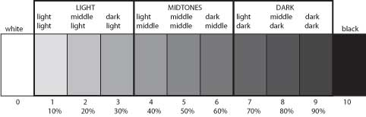

Paint the primary and secondary colours with 5 tonal ranges (the pure colour counts as one range).
Note: Do not use black in any colour that contains yellow (it will turn it a yucky green).
Name: ___________________
/30
RED | YELLOW  (no black) | BLUE | ORANGE  (no black) | VIOLET | GREEN*

