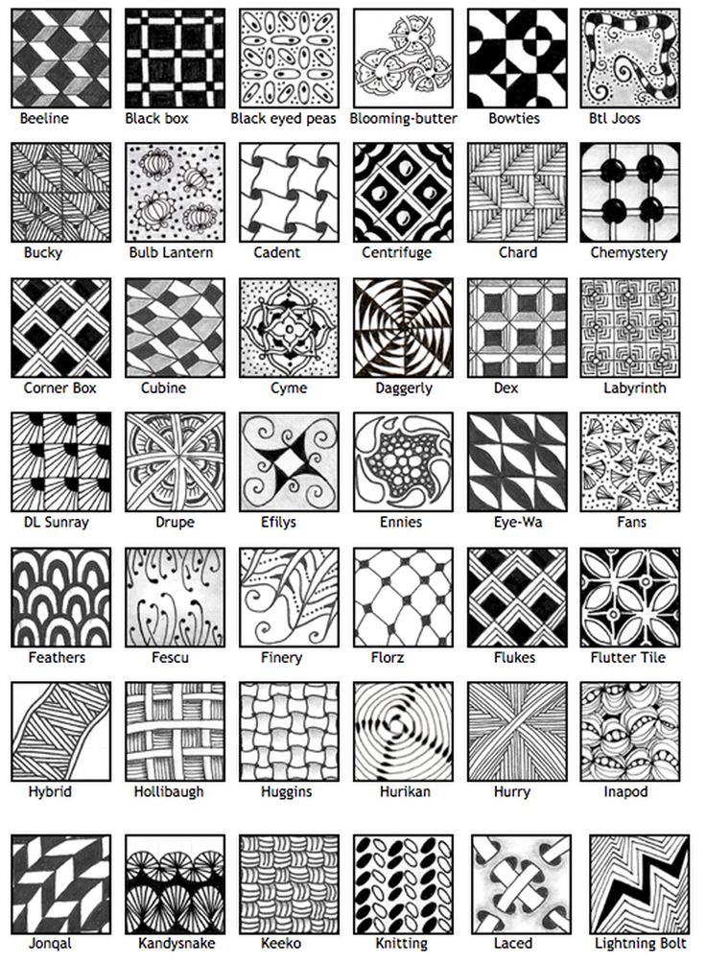

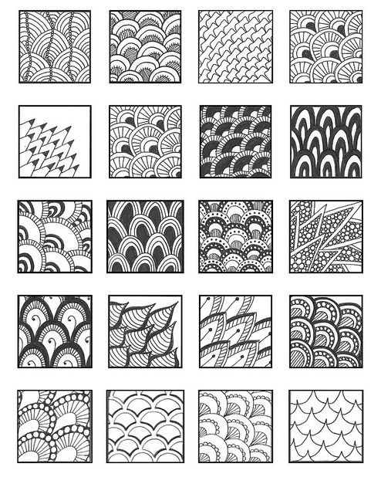[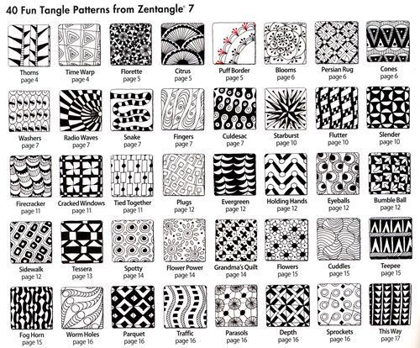](https://www.google.ca/url?sa=i&rct=j&q=&esrc=s&source=images&cd=&cad=rja&uact=8&ved=0ahUKEwjZvubBn-jSAhUk74MKHU3RD2kQjRwIBw&url=https://www.pinterest.com/1LynneHughes/zentangles-doodles/&psig=AFQjCNEqRwMvzL56dotDHTxpgQIR3UmVpA&ust=1490207973119122)